Multi-Threading Assignment-2

1) WAP to show usage of Callable and demonstrate how it is different from Runnable

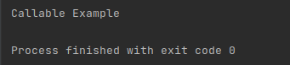

2) Improve the code written in Basics of Multi Threading Part 1 exercise question 4 to handle the deadlock using reentrantlock.

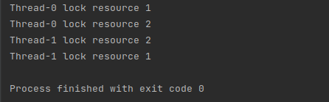

3) Use a singleThreadExecutor, newCachedThreadPool() and newFixedThreadPool() to submit a list of tasks and wait for completion of all tasks.

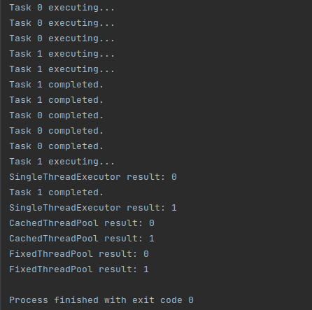

4) WAP to return a random integer value from a thread execution using Future.



5) WAP to showcase the difference between shutdown() and shutdownNow().

